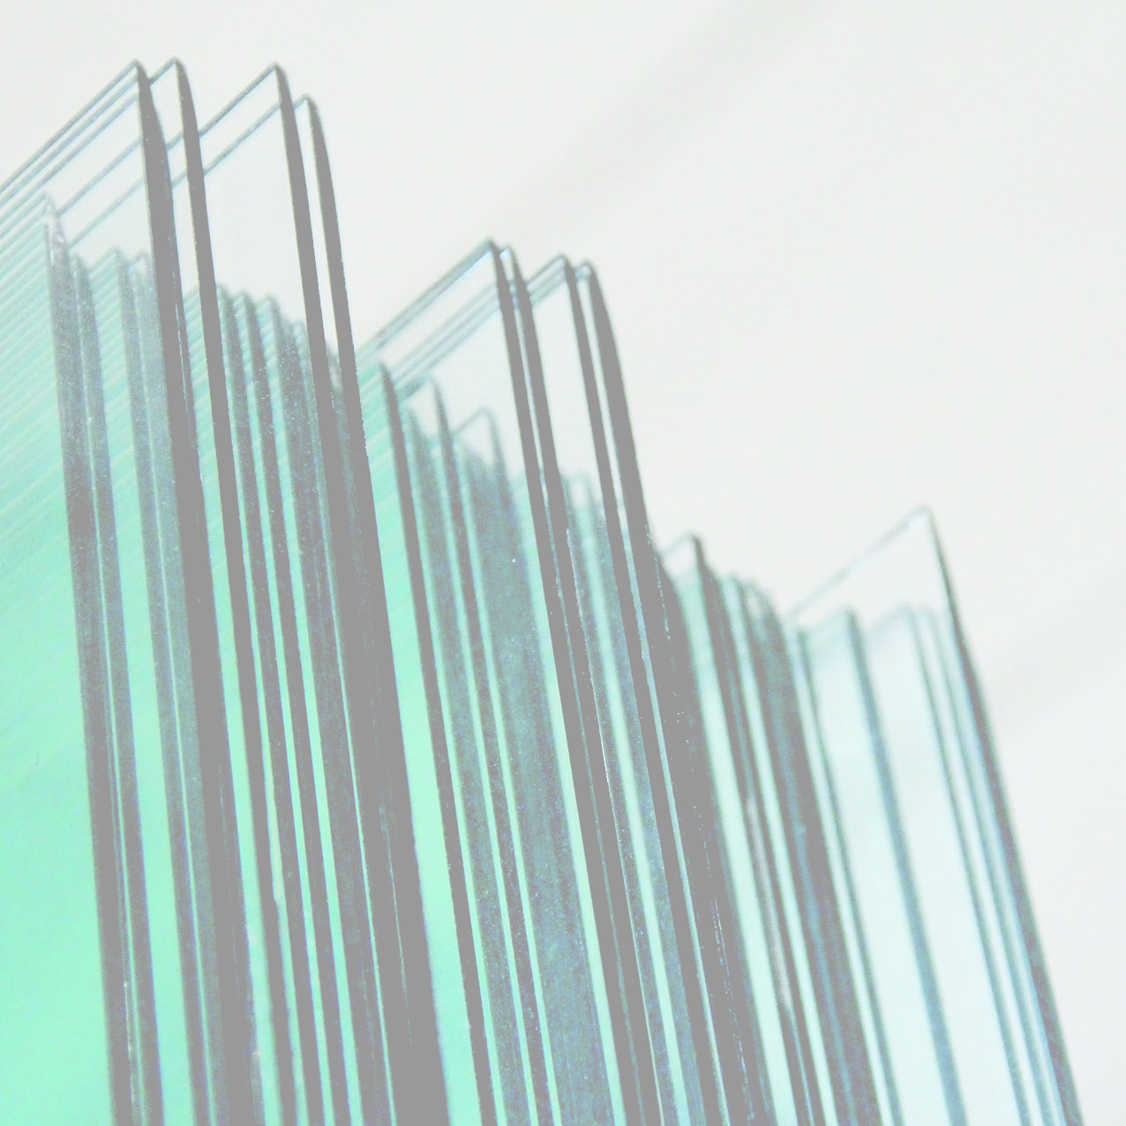
FORATRICE ORIZZONTALE IN LINEA
HORIZONTAL DRILLING MACHINES

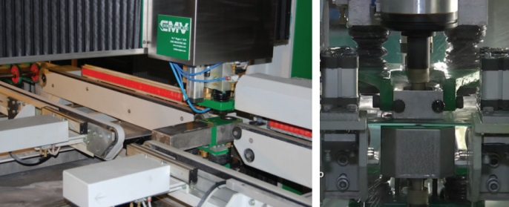
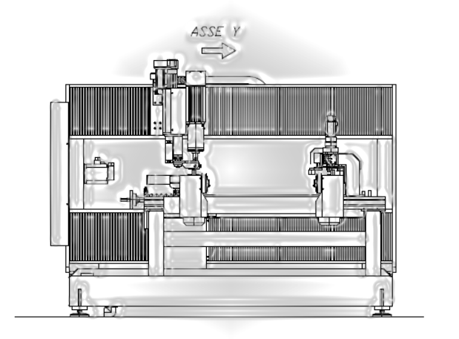
E’ una macchina in orizzontale per l’esecuzione di fori su lastre di vetro a controllo numerico.
E’ composta da un basamento sul quale è montata superiormente una struttura a doppia trave per il supporto dei carri inferiore e superiore che portano i mandrini che compongono l’unità di foratura; sullo stesso basamento è montato il gruppo di trasporto del vetro realizzato da due moduli a cinghie comandati da due motori asincroni e da un carro dotato di riscontro posteriore vetro azionato da motore brushless. La corretta posizione di foratura viene raggiunta traslando l’unità di foratura lungo l’asse Y e il vetro lungo l’asse X. I carrelli con i mandrini di foratura traslano orizzontalmente su guide a ricircolo di sfere, azionati da viti a ricircolo di sfere di precisione e da un motore brushless con riduttore di precisione; l’utilizzo di questi componenti meccanici ed elettronici permette posizionamenti rapidi e precisi. Gli elettromandrini di foratura sono gestiti da inverter trifase che permette di variare la velocità di rotazione da 400 a 4000 giri al minuto; la loro potenza è di 1.5 Kw. Il movimento del mandrino durante la fase di foratura è realizzato su guide a ricircolo di sfere, con l’utilizzo di vite a ricircolo di sfere, comandato da motore brushless. Il posizionamento del vetro viene svolto da un riscontro posteriore vetro montato su un carro che trasla su guide a ricircolo di sfere azionato da motore brushless. Appositi centratori pneumatici laterali assicurano il corretto allineamento alla barra di zero; gli stessi saranno regolati manualmente in funzione della dimensione del vetro. I due moduli di trasporto a cinghie hanno la funzione di ricevere il vetro in arrivo dalla linea a monte e di evacuarlo al termine del ciclo di foratura.

It 'a machine horizontally to the execution of holes on glass plates with numerical control. It is’ consists of a base on which is mounted a double beam structure for supporting the upper and lower carriages which support the spindles that make up the drilling unit; on the same structure it is mounted to the group of transport of the glass realized by two modules belts controlled by two induction motors and by a carriage equipped with rear stopper of the glass actuated by a brushless motor. The correct drilling position is achieved by translating the drilling units along the Y axis and the glass along the axis X. The carriages with the drilling spindles translate horizontally on guides with recirculating ball screws driven by recirculating ball precision and by a brushless motor with precision reduction gear; the use of these mechanical and electronic components allow for quick and accurate positioning. The spindle drilling are operated by three-phase inverter that allows to vary the rotation speed from 400 to 4000 revolutions per minute; their power is 1.5 kW. The movement of the spindle during the drilling phase is realized on recirculating ball bearing, with the use of recirculating ball screw, driven by a brushless motor. The positioning of the glass is carried out by a back gauge glass mounted on a carriage which moves on guides with recirculating ball actuated by a brushless motor. Special centerings tire lateral ensure the correct alignment of the bar to zero; the same will be manually adjusted according to the size of the glass. The two forms of transport belts have the function of receiving the glass coming from the upstream line and evacuate it at the end of the drilling cycle.

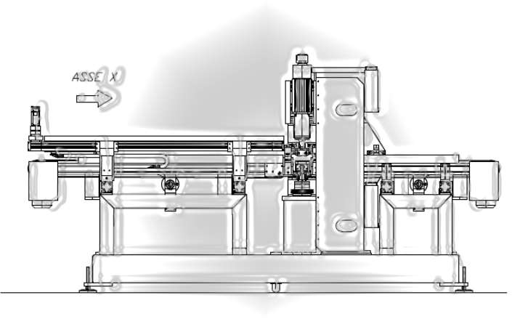

FORATRICE ORIZZONTALE FR-O  Horizontal drilling machines | FR-O-11 | FR-O-21 | FR-O-22 | FR-O-31 | FR-O-32
ALTEZZA PIANO LAVORO  Workbench height | 1000 +/- 50 mm | 1000 +/- 50 mm | 1000 +/- 50 mm | 1000 +/- 50 mm | 1000 +/- 50 mm
CONFIGURAZIONE MANDRINI  Configuration spindles | 1 teste 1 carro  1 head 1 cart | 2 teste 1 carro  2 heads 1 cart | 2 teste 2 carri  2 heads 2 carts | 3 teste 1 carro  3 heads 1 cart | 3 teste 2 carri  3 heads 2 carts
FORMATI MIN.  Min glass dimensions | 180 x 300 mm | 180 x 300 mm | 180 x 300 mm | 180 x 300 mm | 180 x 300 mm
FORMATI MAX. (personalizzabili)  Max. glass dimensions | 1500x2000 mm | 1500x2000 mm | 1500x2000 mm | 1500x2000 mm | 1500x2000 mm
SPESSORE VETRO MIN - MAX  Min – max thickness | 3- 21 mm | 3 - 21 mm | 3 - 21 mm | 3 - 21 mm | 3 - 21 mm
Ø FORATURA MIN. - MAX.  Ø Drilling min. - max. | 3- 60 mm | 3- 60 mm | 3- 60 mm | 3- 60 mm | 3- 60 mm
VELOCITA’ MANDRINI DI FORATURA | 400 / 4500 rpm | 400 / 4500 rpm | 400 / 4500 rpm | 400 / 4500 rpm | 400 / 4500 rpm
Spindle speed
POTENZA TOTALE  Total power | 8 Kw | 14 Kw | 15 Kw | 20 Kw | 21 Kw
VELOCITA’ TRASPORTO  Working speed | 2 – 15 mt/min | 2 - 15 mt/min | 2 - 15 mt/min | 2 - 15 mt/min | 2 – 15 mt/min

